VET BLUE® AND SIGNS OF CONSOLIDATION - SHRED, TISSUE, NODULE & WEDGE SIGN
Gregory R. Lisciandro, DVM, Dipl. ABVP, Dipl. ACVECC
Hill Country Veterinary Specialists & FASTVet.com, Spicewood, Texas USA
Email LearnGlobalFAST@gmail.com
Cell 210.260.5576
Website FASTVet.com
Text Point-of-care Ultrasound Techniques for the Small Animal Practitioner, 2nd Edition, Wiley ©2021

USE OF LUNG ULTRASOUND IN SMALL ANIMALS - THE VET BLUE®
TFAST® (2008), our thoracic FAST protocol, was the first standardized abbreviated veterinary ultrasound exam of the thorax. With the finding of lung pathology during TFAST®, the author extended the lung examination from the TFAST® CTS view to 6 additional transthoracic regional lung views plus the Diaphragmatico-Hepatic view. This novel proactive regional, pattern-based approach to lung ultrasound (LUS) was named Vet BLUE® - “Vet” for “veterinary” and “BLUE” for “brief lung ultrasound exam” also published as "Brief Lung Ultrasound in Emergency." “BLUE” also implies cyanosis. Vet BLUE® was developed in 2010 and is the most studied format in our veterinary literature. However, unless trained by the author, some published "Vet BLUE" studies do not necessarily follow our methodology and thus one of several reasons why we service marked the term for educational purposes to insure its standardized format. Global FAST® is the combined use of AFAST®, TFAST® and Vet BLUE® as a single ultrasound examination used as "an extension of the physical exam."

PATIENT POSITIONING, PREPARATION, PROBE TYPE, PRESET
Positioning. Standing is best being safest and lower impact than the restraint of lateral recumbency. Generally, if a patient is standing, Vet BLUE® and the entire Global FAST® is performed in standing. Dorsal recumbency is never used because it is too risky for hemodynamically fragile or unstable patients. Preparation. Hair is not shaved but parted with minimal amounts of isopropyl alcohol followed by alcohol-based hand sanitizer, which is less noxious and cooling than isopropyl alcohol and is removed more easily than commercially available acoustic coupling gel. The sonographer should make every attempt to part the hair and place the probe as directly as possible on skin to maximize the image quality and minimize “air-trapping” between the probe footprint and the skin. Probe Type. The microconvex probe is used for Vet BLUE® and Global FAST®. A linear probe may be used, but it is not necessary. A phased array (cardiac) probe should be avoided because it does not reliably image the Gator Sign orientation or accurately image numbers of B-lines. Preset. Vet BLUE® and Global FAST® are performed with the abdominal preset. Click here for more information on probe types and Vet BLUE®.

FUNDAMENTAL ORIENTATION FOR ALL LUNG ULTRASOUND - THE GATOR SIGN
The fundamental orientation for all LUS is the "Gator Sign" for accurately identifying the intercostal space (ICS). By identifying the ICS, the “Lung Line” may be identified (also referred to as the pulmonary-pleural interface, parietal-visceral pleura). The author prefers the term "Lung Line" because when pathology exists within the pleural space, the lung is displaced away from the parietal pleura. The scanning plane is oriented perpendicular to the long axis of the ribs with the probe marker toward the head of the patient and screen marker to the left of the screen. Thus, cranial is to the left and caudal to the right of the screen. Depth is set between 4-8 cm using 4 cm for small patients 5-6 cm for medium, and 7-8 cm for larger patients. The transition zones (TZ) are identified by the "Curtain Sign" that demarcates the pleural and abdominal cavities. Without acknowledging the TZ, abdominal structures such as the liver and stomach (rugal folds and ingesta) are often misidentified as lung pathology, i.e., pseudo B-lines, pseudo Shred Sign, pseudo Tissue Sign. Click here for an overviews of Vet BLUE® in our website's Free Resources.

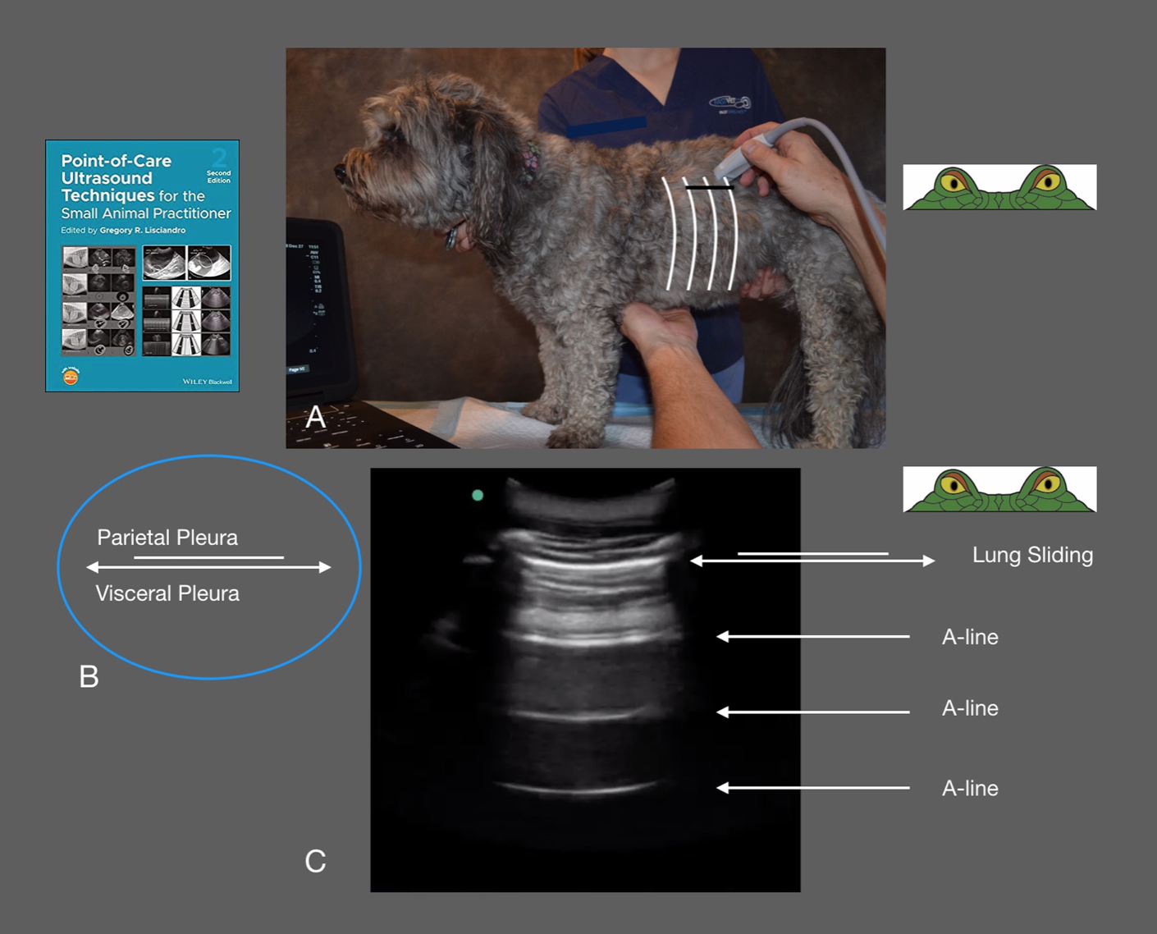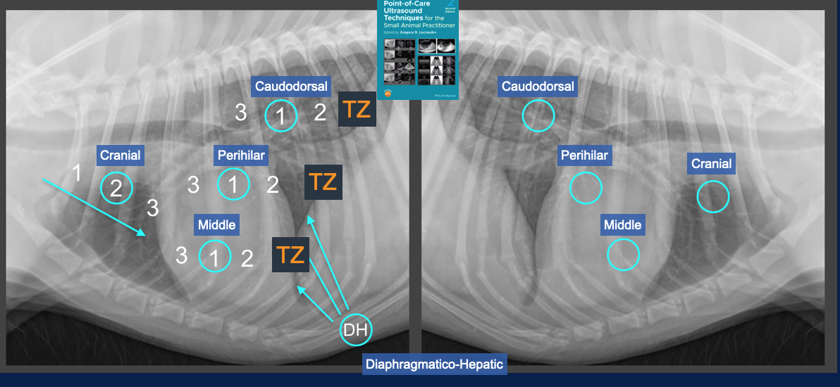
Figure Left. Fundamental "Gator Sign" Orientation for all Lung Ultrasound. This material is reproduced with permission of John Wiley & Sons, Inc., Point-of-Care Ultrasound Techniques for the Small Animal Practitioner, 2nd Edition, Wiley ©2021 and Greg Lisciandro, Hill Country Veterinary Specialists, FASTVet.com.
Figure. Right Vet BLUE® and Its 9-acoustic Windows. Vet BLUE® has the following regional views - caudodorsal, perihilar, middle, and cranial lung regions. Each regional view has a minimum of 3 intercostal spaces evaluated. The Diaphragmatico-Hepatic view is also used as a deep window for lung inaccessible from transthoracic views. This material is reproduced with permission of John Wiley & Sons, Inc., Point-of-Care Ultrasound Techniques for the Small Animal Practitioner, 2nd Edition, Wiley ©2021 and Greg Lisciandro, Hill Country Veterinary Specialists, FASTVet.com.

VET BLUE® - WET VERSUS DRY LUNG CONCEPT
Dry Lung. Dry aerated lung at its surface is hallmarked by a bright white, hyperechoic “Lung Line” with “Lung Sliding” and A-lines repeating through the far field. "Lung Sliding" is the "to and fro" motion of the lung surface moving cranial and caudal with phases of respiration. It is expected that lung is dry at all views during Vet BLUE® with uncommon single B-lines. Wet Lung. Forms of alveolar-interstitial edema create an artifact referred to as B-lines also called ultrasound lung rockets. B-lines are most commonly "water, blood or pus." Water being cardiogenic and non-cardiogenic pulmonary edema, blood being lung hemorrhage in coagulopathic patients, or lung contusions in trauma (more here), and pus being pneumonia. The use of “B” in B-lines is only because “B” follows “A” in the alphabet. These vertical laser-like bright white, hyperechoic artifacts originate from the “Lung Line” and extending through the far field without fading while swinging like a pendulum in synchrony with phases of respiration. Their presence is referred to as alveolar-interstitial syndrome because a regional, pattern-based approach is needed for developing a working diagnosis as to their cause along with integrating other Global FAST® findings. B-lines are scored - see Figure. "Pseudo B-lines" are created by nodules (Nodule Sign) and gastric contents (pseudo gastric B-lines) terms created by the author and published in our peer-reviewed literature. Click here for Vet BLUE® and wet versus dry lung in our website's Free Resources.

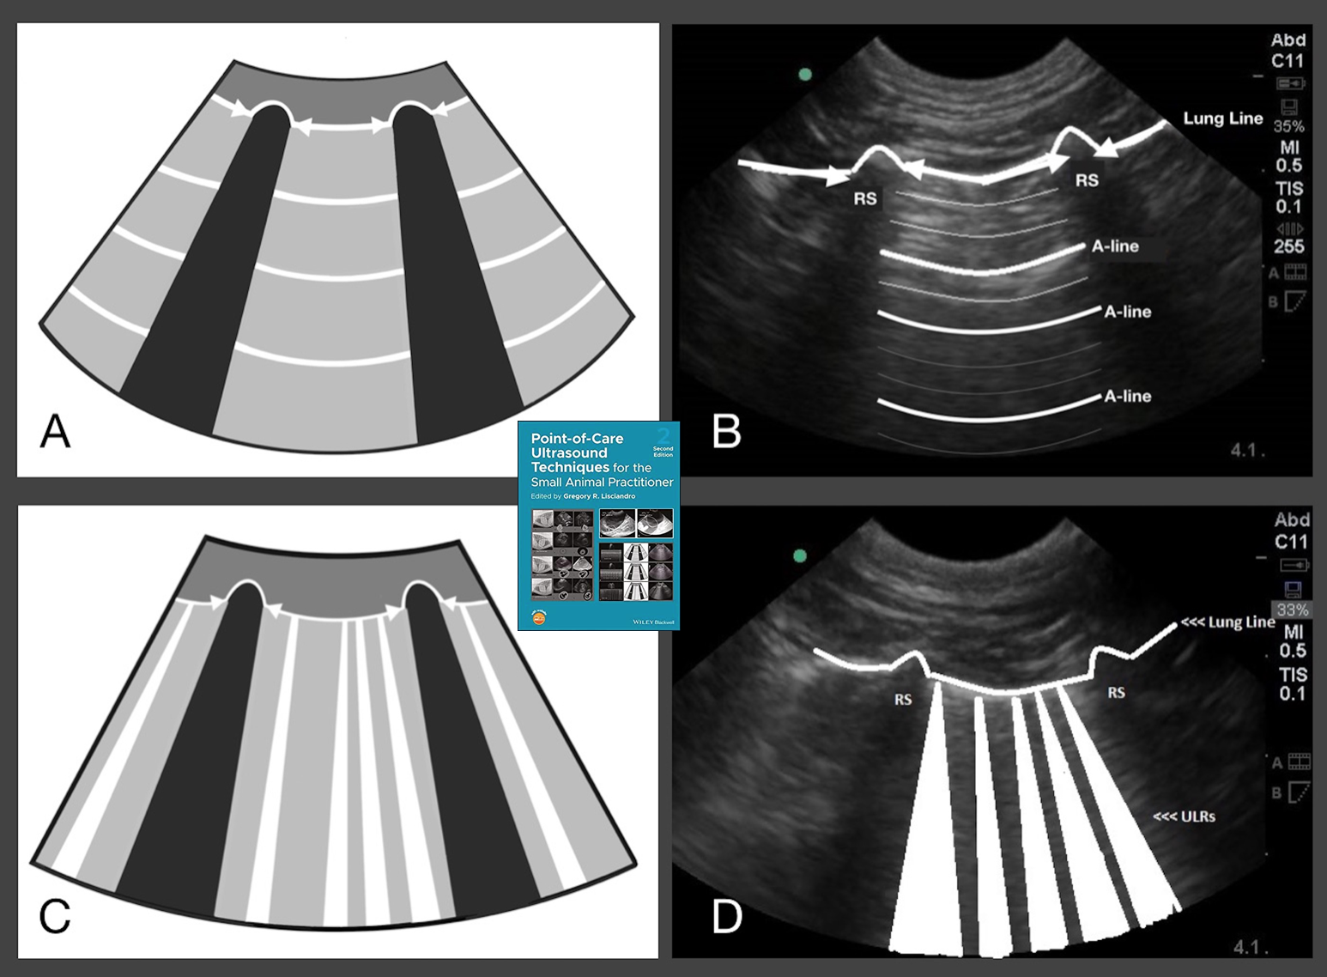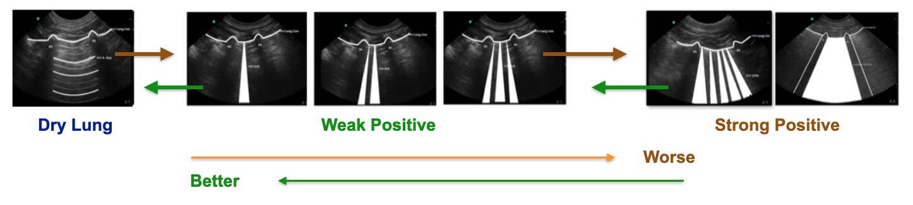

Figure Left. Dry Lung and Wet Lung. This material is reproduced with permission of John Wiley & Sons, Inc., Point-of-Care Ultrasound Techniques for the Small Animal Practitioner, 2nd Edition, Wiley ©2021 and Greg Lisciandro, Hill Country Veterinary Specialists, FASTVet.com.
Figure Right. B-line Scoring System. We expect dry lung all views with uncommon single B-lines in dogs and cats and likely all adult mammalian lung. The B-line scoring is 1, 2, 3 as "weak positives" and >3, and infinity, "strong positives" taken as the highest number over a single intercostal space at each respective Vet BLUE® regional view. B-lines and their distribution are a Vet BLUE® inherent severity scoring system and may also be used as a guide to loop diuretic therapy in left-sided congestive heart failure and as a tracking tool. This material is reproduced with permission of John Wiley & Sons, Inc., Point-of-Care Ultrasound Techniques for the Small Animal Practitioner, 2nd Edition, Wiley ©2021 and Greg Lisciandro, Hill Country Veterinary Specialists, FASTVet.com.

VET BLUE® VISUAL LUNG LANGUAGE - SIGNS OF CONSOLIDATION
The Vet BLUE® signs of consolidation - Shred Sign (air bronchogram, pneumonia here), Tissue Sign (hepatization of lung), Nodule Sign (organized consolidation), and Wedge Sign (pulmonary thromboembolism, more here) have been described and when placed in a regional, pattern-based approach (their distribution) a respiratory working diagnosis can be formulated. Of note, the Nodule Sign and Wedge Sign (and pseudo B-lines) were created by the author and have been published in our peer-reviewed literature (Ward et al. JAVMA 2019, Pacholec et al. 2021, Lisciandro et al. 2022).

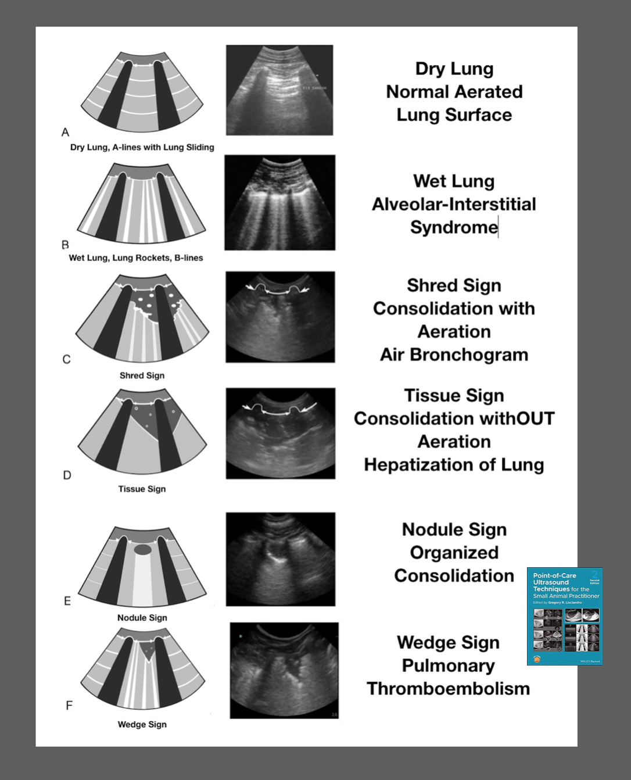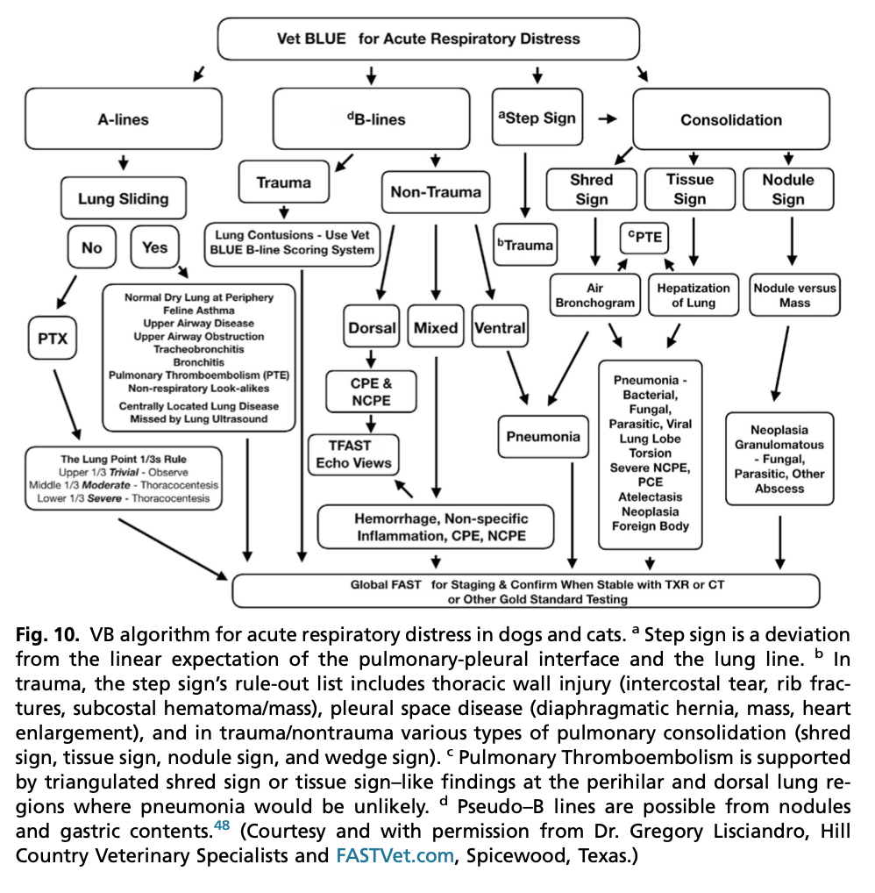

Figure. Vet BLUE® Visual Lung Language and Its 6 Signs. Vet BLUE® Visual Lung Language from most to least normal, from less severe to more severely affected lung, is as follows: Dry Lung to Wet Lung (B-lines, alveolar-interstitial edema) to Shred Sign (air bronchogram) to Tissue Sign (hepatization of lung) to Nodule Sign to Wedge Sign (pulmonary thromboembolism). This material is reproduced with permission of John Wiley & Sons, Inc., Point-of-Care Ultrasound Techniques for the Small Animal Practitioner, 2nd Edition, Wiley ©2021 and Greg Lisciandro, Hill Country Veterinary Specialists, FASTVet.com.
Table. Flow chart of Vet BLUE® signs with common respiratory conditions using its regional, pattern-based approach. This material is reproduced with permission of John Wiley & Sons, Inc., Point-of-Care Ultrasound Techniques for the Small Animal Practitioner, 2nd Edition, Wiley ©2021 and Greg Lisciandro, Hill Country Veterinary Specialists, FASTVet.com.

BACTERIAL, FUNGAL, AND VERMINOUS PNEUMONIA IN SMALL ANIMALS
Aspiration and bacterial bronchopneumonia have a gravity dependent predominance i.e., middle, and cranial Vet BLUE® lung regions, that is asymmetrical. Findings of aspiration and bacterial bronchopneumonia range from B-lines (mildest) to Shred Sign (air bronchograms, moderate to severe) to Tissue Sign (hepatization, severe). The classic lung lobe affected in dogs with aspiration pneumonia is the right middle lung lobe. The finding of B-lines would be mild aspiration versus signs of consolidation (Shred and Tissue Sign). More severe aspiration or bacterial bronchopneumonia would involve more Vet BLUE® regions i.e., cranial, and middle lung regions unilaterally to bilaterally. By recording Vet BLUE® findings, patients may have their clinical course followed point-of-care without the risk and restraint involved in radiology once diagnosed. The finding of dry lung all Vet BLUE® views rules out all clinically relevant wet lung conditions. The use of serial (repeat) Vet BLUE® would (logic would dictate) increase the accuracy of the test either while patients are hospitalized or return for recheck exams. Verminous and fungal pneumonias are granulomatous so the Nodule Sign may be found. It is important to consider that not all nodules are neoplastic, can include granulomatous pneumonias, and abscess, i.e., foreign body, penetrating trauma, and other less common nodular pathology.
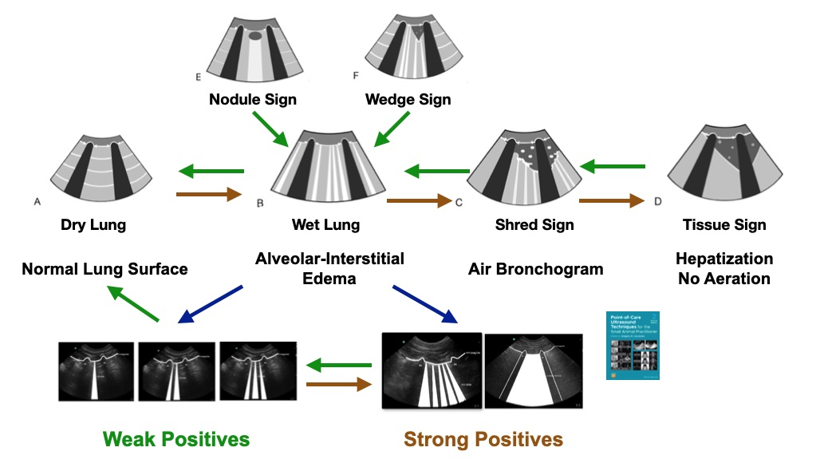

Figure. Use of Vet BLUE® for Tracking All Respiratory Conditions Evident on Vet BLUE®. B-lines may further be subdivided into "weak" and "strong" positives. This material is reproduced with permission of John Wiley & Sons, Inc., Point-of-Care Ultrasound Techniques for the Small Animal Practitioner, 2nd Edition, Wiley ©2021 and Greg Lisciandro, Hill Country Veterinary Specialists, FASTVet.com.

SHRED, TISSUE, NODULE, AND WEDGE SIGN
The Shred Sign is hallmarked by air within the consolidation. These punctate and linear bright white hyperechoic areas are air bronchograms. In gravity dependent middle and cranial Vet BLUE® lung regions, bacterial pneumonia/aspiration pneumonia would be a top rule out, click here. The Tissue Sign is hallmarked by complete consolidation with no aeration. The Nodule Sign a black anechoic-hypoechoic oval or circle with a pseudo B-line extending from its far border through the far field. The Wedge Sign, an amalgam of the Shred and Tissue Sign that is wedge-shaped as expected with vascular infarction. In upper non-dependent Vet BLUE® regions of caudodorsal and perihilar, pulmonary thromboembolism should be suspected. These signs should be combined with the clinical profile of the patient and their distribution using Vet BLUE®'s regional, pattern-based, approach for a working diagnosis. Air bronchograms may be further subdivided into "dynamic" (more likely pneumonia) and "static" (more likely atelectasis) air bronchograms, and color flow and power Doppler may be used to differentiate vessels, fluid bronchograms, lung lobe torsion, and vascular infarction. However, movement will make such observations challenging in many spontaneously ventilating patients.

INTEGRATING VET BLUE® INFORMATION WITH TFAST® AND GLOBAL FAST® FINDINGS
Minimally Vet BLUE® should be integrated with TFAST® findings including TFAST® fundamental echocardiography and the Diaphragmatico-Hepatic view (caudal vena cava and hepatic venous characterization) for differentiating pneumonia from other wet lung conditions (and for detecting complications such as pulmonary hypertension).
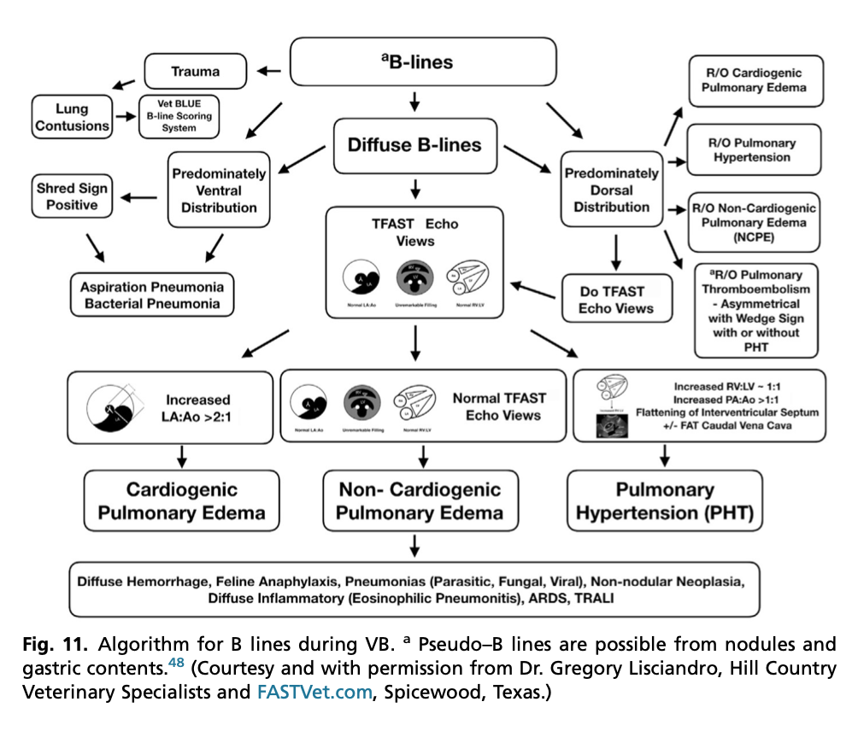

Table. Flow chart integrating Vet BLUE® with TFAST® and characterization of the caudal vena cava and hepatic veins. This material is reproduced with permission of John Wiley & Sons, Inc., Point-of-Care Ultrasound Techniques for the Small Animal Practitioner, 2nd Edition, Wiley ©2021 and Greg Lisciandro, Hill Country Veterinary Specialists, FASTVet.com.

COMPARISON OF VET BLUE® TO THORACIC RADIOGRAPHY AND COMPUTED TOMOGRAPHY
Vet BLUE® is proving itself as a more sensitive test than thoracic radiography for wet lung conditions (types of alveolar-interstitial edema) performing closer to computed tomography (CT) (Ward, Lisciandro, DeFrancesco JVECC 2018, Dicker et al. JVECC 2020, click here). Vet BLUE® also serves as a rapid lung metastasis check and in one of our studies performed similar to radiography (Kulhavy and Lisciandro [Abstract] JVECC 2015, Pacholec et al. Vet Journal 2021); however, CT is clearly superior for nodules. In our experience, Vet BLUE® detects lung surface pathology that is less defined or completely missed by plain radiography, thus serving as a screening test for deciding on additional imaging, or as an adjunct/compliment to radiography.

RECORDING FINDINGS ON GOAL-DIRECTED TEMPLATES
Recording Vet BLUE® findings on goal-directed templates are imperative for success. Click here.

REFERENCES & FURTHER READING
- Lisciandro GR, Lisciandro SC. Chapter 22: POCUS: Vet BLUE-Introduction and Image Acquisition and Chapter 23: POCUS: Vet BLUE-Clinical Integration. In Point-of-care Ultrasound Techniques for the Small Animal Practitioner, 2nd Edition, Ed. Lisciandro GR. Wiley Blackwell: Ames IA 2021.
- Lisciandro GR, Fosgate GT, Fulton RM. Frequency of ultrasound lung rockets using a regionally-based lung ultrasound examination named veterinary bedside lung ultrasound exam (Vet BLUE) in 98 dogs with normal thoracic radiographic lung findings. Vet Rad Ultrasound 55(3):315-22.
- Ward JL, Lisciandro GR, Ware WA, Miles KG, DeFrancesco TC. Lung ultrasound findings in 100 dogs with various etiologies of cough. J Am Vet Med Assoc 2019:255(5):574-583.
- Dicker SA, Lisciandro GR, Newell SM, et al. Diagnosis of pulmonary contusions with point-of-care lung ultrasonography and thoracic radiography compared to thoracic computed tomography in dogs with motor vehicle trauma: 29 cases (2017-2018). J Vet Emerg Crit Care, 2020 30(6):638-646.
- Pacholec C, Lisciandro GR, Masseau I, et al. Lung ultrasound nodule sign for detection of pulmonary nodule lesions in dogs: Comparison to thoracic radiography using computed tomography as the criterion standard. Vet J 2021 Jul 31;105727. doi: 10.1016/j.tvjl.2021.105727. Online ahead of print.
- Chou Y, Ward JL, Baron LZ, Murphy SD, Topf MA, Lisciandro GR, et al. Focused ultrasound of the caudal vena cava in dogs with cavitary effusions or congestive heart failure: a prospective observational study. PLoS One 2021;16(5):e0252544. doi:10.1371/journal.pone.0252544
- Ward JL, Murphy SD, Lisciandro GR, et al. Comparison of curvilinear-array (microconvex) and phased-array transducers for ultrasonography of the lungs in dogs. Am J Vet Res 2021:82(8);619-628.
- Vientós-Plotts AI, Wiggen KE, Lisciandro GR, et al. The utility of point-of-care ultrasound non-echo right-sided cardiac markers as a screening test for moderate to severe pulmonary hypertension in dogs. Vet J 2019; 250:6-13.
- Lisciandro GR, Puchot ML, Gambino JM, Lisciandro SC. The Wedge Sign: A Possible Lung Ultrasound Sign for Pulmonary Thromboembolism. J Vet Emerg Clin Care 2022;32(5):663-669.
- Lichtenstein DA, Lascos N, Meziere GA, et al. Ultrasound diagnosis of alveolar consolidation in the critically ill Intensive Care Med 2004; 30: 276-281.

Lichtenstein D, Mezière G, Seitz J. The dynamic air bronchogram. A lung ultrasound sign of alveolar consolidation ruling out atelectasis. Chest 2009; 135(6): 1421-1425.
- Volpicelli G, Mussa A, Garofalo G, et al. Bedside lung ultrasound in the assessment of alveolar-interstitial syndrome. Am J Emerg Med 2006;24: 689-696.
- Volpicelli G, Elbarbary M, Blaivas M, et al. International evidence-based recommendations for point-of-care lung ultrasound. Intensive Care Med 2012; 38:577-91.
- Testa A, Soldati G, Coperti R, et al. Early recognition of the 2009 pandemic influenza A (H1N1) pneumonia by chest ultrasound. Critical Care 2012;2:16:R30.
Gibbons RC, Magee M, Goett H, et al. Lung ultrasound vs. chest X-ray study for the radiographic diagnosis of COVID-19 pneumonia in a high-prevalence population. Ultrasound Emerg Med 2021;60(5):615-625.

*A summary of all our 20+ peer-reviewed clinical studies may be found here.

