**VET BLUE® INTRODUCTION TO LUNG ULTRASOUND & WET VERSUS DRY LUNG PRINCIPLES**

Gregory R. Lisciandro, DVM, Dipl. ABVP, Dipl. ACVECC

Hill Country Veterinary Specialists & FASTVet.com, Spicewood, Texas USA

Email [LearnGlobalFAST@gmail.com](mailto:FastSavesLives@gmail.com)

Cell 210.260.5576

Website FASTVet.com

Text [Point-of-care Ultrasound Techniques for the Small Animal Practitioner](https://www.amazon.com/Point-Ultrasound-Techniques-Animal-Practitioner/dp/1119460980/ref=sr_1_1?crid=2W3RO79YXBLKT&keywords=Lisciandro+ultrasound&qid=1674252243&sprefix=lisciandro+ultrasoun%2Caps%2C203&sr=8-1), 2nd Edition, Wiley ©2021

**Use of Lung Ultrasound in Small Animals - The Vet BLUE®**

TFAST® (2008), our thoracic FAST protocol, was the first standardized abbreviated veterinary ultrasound exam of the thorax. With the finding of lung pathology during TFAST®, the author extended the lung examination from the TFAST® CTS view to 6 additional transthoracic regional lung views plus the Diaphragmatico-Hepatic view. This novel proactive regional, pattern-based approach to lung ultrasound (LUS) was named Vet BLUE® - “Vet” for “veterinary” and “BLUE” for “brief lung ultrasound exam” also published as "Brief Lung Ultrasound in Emergency." “BLUE” also implies cyanosis. Vet BLUE® was developed in 2010 and is the most studied format in our veterinary literature. However, unless trained by the author, some published "Vet BLUE" studies do not necessarily follow our methodology and thus one of several reasons why we service marked the term for educational purposes to insure its standardized format. Global FAST® is the combined use of AFAST®, TFAST® and Vet BLUE® as a single ultrasound examination used as "an extension of the physical exam."

**The Fundamentals of Vet BLUE®**

***Patient Preparation.*** Vet BLUE® sites are not shaved!All images shown by the speaker are from unshaved sites. To optimize the image quality, the hair is wetted with minimal amounts of 70% isopropyl alcohol, the hair parted to expose the skin, followed by the application of alcohol-based hand sanitizer gel and the probe head then directly opposed to skin. A common mistake is placing the probe footprint on a wetted mat of hair, which leads to the phenomenon of "air trapping" within the wetted mat. "Air trapping" causes the deflection of the echoes from the probe because ultrasound cannot transmit through air; and minimizing the numbers of echoes making it to the region of interest compromises image quality. ***Patient Positioning.***Vet BLUE® is preferably performed in standing (or sternal) which is safer for respiratory compromised, those in respiratory distress, and those that are hemodynamically fragile or unstable. A roll of paper towels under the forelegs of a cat is an easy, tolerated maneuver to gain access to the ventral middle and cranial Vet BLUE® regional views, and the TFAST® PeriCardial Site views. Vet BLUE® may also be performed in dogs and cats in lateral recumbency when they are laterally recumbent. The concept that "air rises" to least gravity-dependent regions and that "fluid falls" to the most gravity-dependent regions should be acknowledged relative to patient positioning. This concept is especially important when drawing conclusions regarding pneumothorax (PTX) because free air in the pleural cavity (rises); and pleural effusion (PE) (falls) into gravity dependent areas we call "pouches." Pericardial effusion (PCE) also falls into gravity dependent regions but is contained within the pericardial sac. ***Probe Type****.* The curvilinear (convex) probe is the preferred probe in human medicine by the non-radiologist. In veterinary medicine, the curvilinear (microconvex) probe is also preferred because it may be used to image all aspects of the Global FAST® Approach, which includes AFAST®, TFAST®, and Vet BLUE®. The linear probe may also be used and provides exceptional detail of the lung surface; however, its disadvantage is that it cannot be used for the entire Global FAST®. The phased-array cardiac probe should be avoided because it cannot accurately identify the "Gator Sign" orientation or accurately count numbers of B-lines. Read this blog based on our clinical research [here](https://fastvet.com/ecc-and-im-blog-may-2022-the-probe-matters-for-lung-ultrasound/). ***Probe Frequency.*** Generally, frequencies of 10-5 MHz adequately image lung. Other considerations that affect the image include the focus position, which should be across or just below the “Lung Line”, the time gain compensation (TGC) and the overall gain, that is generally turned down for more contrast; however, with enough gain to image through the far field, and the preset. The speaker uses the abdominal preset for the entire Global FAST® Approach, including lung and heart during TFAST® and Vet BLUE®. ***Lung Imaging Orientation.*** All LUS orientation is founded on the visualization of the “Gator Sign” for its importance in properly identifying the intercostal space (ICS). By identifying the ICS, the “Lung Line” may be identified, which has also been referred to as the pulmonary-pleural interface, where visceral and parietal pleura are directly opposed. The other prefers the macro description of lung surface sliding along the ICS. The transverse orientation may also be used but care must be taken to follow the "Lung Line" from the Gator Sign to the transverse orientation so that the white hyperechoic line of the lung surface is followed. By not doing so fascial planes, the stomach wall, the spine of the scapular, air reverberation artifact, A-lines, may be mistaken for the "Lung Line." **Tricks of the Trade.** The "One-eyed Gator Sign" (rib in the center of the screen) is a FASTVet original and manipulating the angle of insonation when imaging the “Lung Line” optimize the observation of "Lung Sliding", which is the visualization of the lung moving along the intercostal space with phases of respiration much like an Etch-a-sketch® cursor***. Lung Line.*** We prefer to use “Lung Line” term for the lung surface because when pathology exists within the pleural space, the lung is displaced away from the parietal pleura.

***Screen Orientation and Depth.*** The scanning plane is oriented perpendicular to the long axis of the ribs with the probe marker and screen orientation marker toward the head and to the left of the screen, respectively. By doing so, the head will be to the left of the screen (cranial) and the tail to the right of the screen (caudal). Our mantra is "make everything like a lateral radiograph (all images of the abdomen and thorax)." Depth is generally set between 4-8 cm with a good way to remember is the L-U-N-G has 4 letters, so start with 4 cm for small dogs and cats and increase to 8 cm (sometimes greater) for large dogs. ***Final Point Pearl and Pitfall.*** If the “Gator Sign” is not identified then other bright white or hyperechoic lines can easily be mistaken for the “Lung Line” including the spine of the scapula, an air-filled stomach, A-lines, and even fascial planes within thorax-associated muscle.

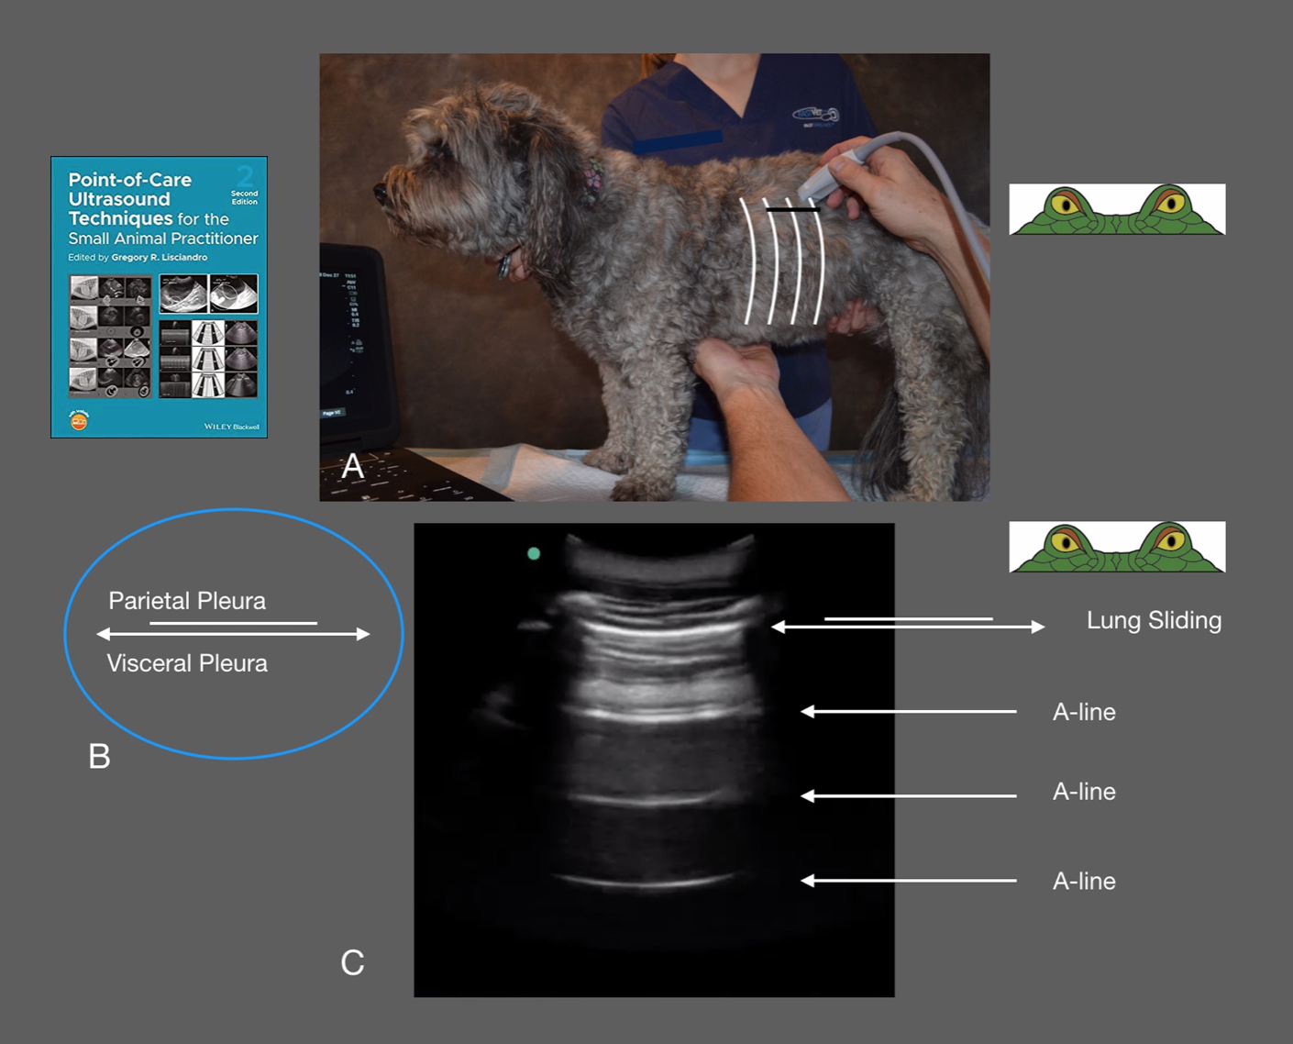

**Figure Left.** **Gator Sign Orientation.** The rounded ribs are likened to the eyes, and the bright white hyperechoic “Lung Line” or “pulmonary-pleural interface” in between ribs in the intercostal space likened to the bridge of its nose as a partially submerged alligator (gator) peers at the sonographer. This orientation is fundamental for ALL lung ultrasound to ensure one accurately identifies where lung is expected to be in normalcy, referred to as the “Lung Line” in along the ICS. *This material is reproduced with permission of John Wiley & Sons, Inc.,* [*Point-of-Care Ultrasound Techniques for the Small Animal Practitioner*](https://www.amazon.com/Point-Ultrasound-Techniques-Animal-Practitioner/dp/1119460980/ref=sr_1_1?crid=2W3RO79YXBLKT&keywords=Lisciandro+ultrasound&qid=1674252243&sprefix=lisciandro+ultrasoun%2Caps%2C203&sr=8-1)*, 2nd Edition, Wiley ©2021 and FASTVet.com © 2014, 2021.*

**Figure Right. Selecting the Vet BLUE**® **Line and Vet BLUE® B-line Scoring.** *This material is reproduced with permission of John Wiley & Sons, Inc.,* [*Point-of-Care Ultrasound Techniques for the Small Animal Practitioner*](https://www.amazon.com/Point-Ultrasound-Techniques-Animal-Practitioner/dp/1119460980/ref=sr_1_1?crid=2W3RO79YXBLKT&keywords=Lisciandro+ultrasound&qid=1674252243&sprefix=lisciandro+ultrasoun%2Caps%2C203&sr=8-1)*, 2nd Edition, Wiley ©2021 and Greg Lisciandro, Hill Country Veterinary Specialists, FASTVet.com © 2014, 2021.*

**The Vet BLUE**® **- Its 9 Acoustic Windows**

***How to Perform.*** The Vet BLUE® begins at the CTS view of TFAST® and establishing the “Gator Sign” orientation. The probe is then moved through regional views that are bilaterally applied as follows: caudodorsal lung region, perihilar lung region, middle lung region, and lastly the cranial lung region. The Caudodorsal Transition Zone (CdTZ) is located by starting directly above the xiphoid in the upper third of the thorax and locating the “Curtain Sign of lung ultrasound” that differentiates the pleural from abdominal cavities. If it is not immediately located, the probe is generally slid caudally searching for obvious abdominal structures and then sliding cranially finding the “Curtain Sign of lung ultrasound.” The principle is very important because abdominal structures are easily mistaken for lung pathology without this training. The probe is then slid 3 ICSs cranial to the CdTZ for your starting Vet BLUE® view, the caudodorsal lung region view. From there survey 3 ICSs, one caudal and one cranial from your starting point. Drawing a line to the elbow is performed next. This is your "Vet BLUE® Line." Approximately halfway is the perihilar lung region, and at the proximity of the elbow is the middle lung region. The probe is then slid cranio-dorsal into the thoracic inlet to find the Cranial Transition Zone (CrTZ). From the CrTZ the probe is slid caudally over "the first rib, first ICS, the second rib, second ICS, third rib, third ICS."

**Vet BLUE® - "Wet Lung" versus "Dry Lung" Concept**

***Dry Lung.*** Dry aerated lung at its surface is defined as a bright white, hyperechoic “Lung Line” accompanied with “Lung Sliding” and equidistant A-lines repeating through the far field. Remember A-lines as "air reverberation" artifact because “Air” begins with the letter “A.” “Lung sliding” is the "to and fro" motion of the lung sliding along the ICS much like an Etch-a-Sketch® cursor moving "to and fro." The micro description for “Lung Sliding” is the sliding of parietal and visceral pleura. On a macro level, “Lung Sliding” is the lung surface sliding along the intercostal space. The distinguishing feature between normal aerated lung on its surface and pneumothorax (PTX) is presence and absence of “Lung Sliding”, respectively. Each of these conditions is hallmarked by a strong air interface at the ICS. Expect absent B-lines or "Dry Lung" at all Vet BLUE® views in adult dogs and cats and puppies and kittens over 6-weeks of age. A single B-line at a single regional view is uncommon but can support a “Dry Vet BLUE® profile.” The bottom line, place any and all B-lines during Vet BLUE® in clinical context and record your findings on [Goal-directed Templates (GDTs)](https://fastvet.com/most-updated-global-fast-goal-directed-templates/) for future comparison. ***Wet Lung.*** Alveolar-interstitial edema creates a unique artifact referred to as ultrasound lung rockets or B-lines, terms that may be used interchangeably. The use of “B” in B-lines is only because “B” follows “A” in the alphabet. The vertical laser-like bright white, hyperechoic linear streaks originate off the “Lung Line” while extending through the far field *without* fading while swinging like a pendulum in synchrony with phases of respiration and obliterating A-lines. Their presence is referred to as alveolar-interstitial syndrome (AIS) because a pattern-based approach is needed for developing a working diagnosis as to AIS characterization ("water, blood, or pus"). The vertical artifact is caused by the cuffing of alveoli around the edema resulting in a near field aperture and acoustic chamber. "**Pseudo B-lines"** is a term created and published by the speaker to describe non-AIS causes such as nodules and gastric ingesta. The Vet BLUE® B-line Scoring System divides B-lines into "Weak Positives" as 1,2, and 3 and "Strong Positives" as >3 and infinity (∞).

***Expectations of "Wet Lung" versus "Dry Lung" Artifacts in Normalcy***

From our Vet BLUE® research, expect "Dry Lung All Vet BLUE® Views" in adult dogs and cats and puppies and kittens over 6-weeks of age. A single B-line at a single regional view is uncommon but can be also support a “Dry Lung" Vet BLUE® profile. The bottom line is to place all B-lines during Vet BLUE® in clinical context and record your findings for future comparison.

**Quick Facts - B-lines or Ultrasound Lung Rockets do the Following:**

* Immediately rule out PTX at that location along the thoracic wall
* Represent lung contusion in trauma until proven otherwise
* Guide diuretic use in left-sided congestive heart failure patients
* Guide and track therapy for all "Wet Lung" conditions
* Their absence with "Dry Lung all Vet BLUE® views" rules out *all* common "Wet Lung" conditions including left-sided congestive heart failure, all forms of non-cardiogenic pulmonary edema, pneumonia, pulmonary hemorrhage, and lung contusions

**Using Wet Lung versus Dry Lung for a Vet BLUE® Working Diagnosis**

It is important to work through the following cases and what would be expected in each common respiratory scenario barring complications in dogs and cats: left-sided congestive heart failure; non-cardiogenic pulmonary edema (electrocution, strangulation, neurogenic, ARDS); tracheal collapse, laryngeal paralysis, infectious tracheobronchitis (CIRD, canine infectious respiratory disease), aspiration pneumonia, bacterial, fungal, and verminous pneumonias, pericardial effusion, pyrexia/fever/heat stroke, feline asthma, canine bronchial disease, and anaphylaxis.

**Vet BLUE® and Its Inherent Severity Scoring System**

The use of the Vet BLUE® B-lines Scoring System combined with their distribution over the regional Vet BLUE® views provide an inherent severity score.

**Figure. The Vet BLUE® B-line Scoring System.** The Vet BLUE® B-line Scoring System serves as an inherent severity scoring system and is used for tracking patients as static, worsening (A to C), improving (C to A), and complete resolution ("Dry All Vet BLUE**®** Views"). Shown is a case example of left-sided congestive heart failure; however, this severity scoring may be used for all "Wet Lung" conditions. *This material is reproduced with permission of John Wiley & Sons, Inc.,* [*Point-of-Care Ultrasound Techniques for the Small Animal Practitioner*](https://www.amazon.com/Point-Ultrasound-Techniques-Animal-Practitioner/dp/1119460980/ref=sr_1_1?crid=2W3RO79YXBLKT&keywords=Lisciandro+ultrasound&qid=1674252243&sprefix=lisciandro+ultrasoun%2Caps%2C203&sr=8-1)*, 2nd Edition, Wiley ©2021 and Greg Lisciandro, Hill Country Veterinary Specialists, FASTVet.com © 2014, 2021.*

**Vet BLUE® Visual Lung Language for Signs of Consolidation**

Vet BLUE® signs of consolidation include the "Shred Sign" (air bronchogram), "Tissue Sign" (hepatization of lung), "Nodule Sign" (we created and published the term), and "Wedge Sign" (pulmonary embolism/thromboembolism) (we created and published the term).

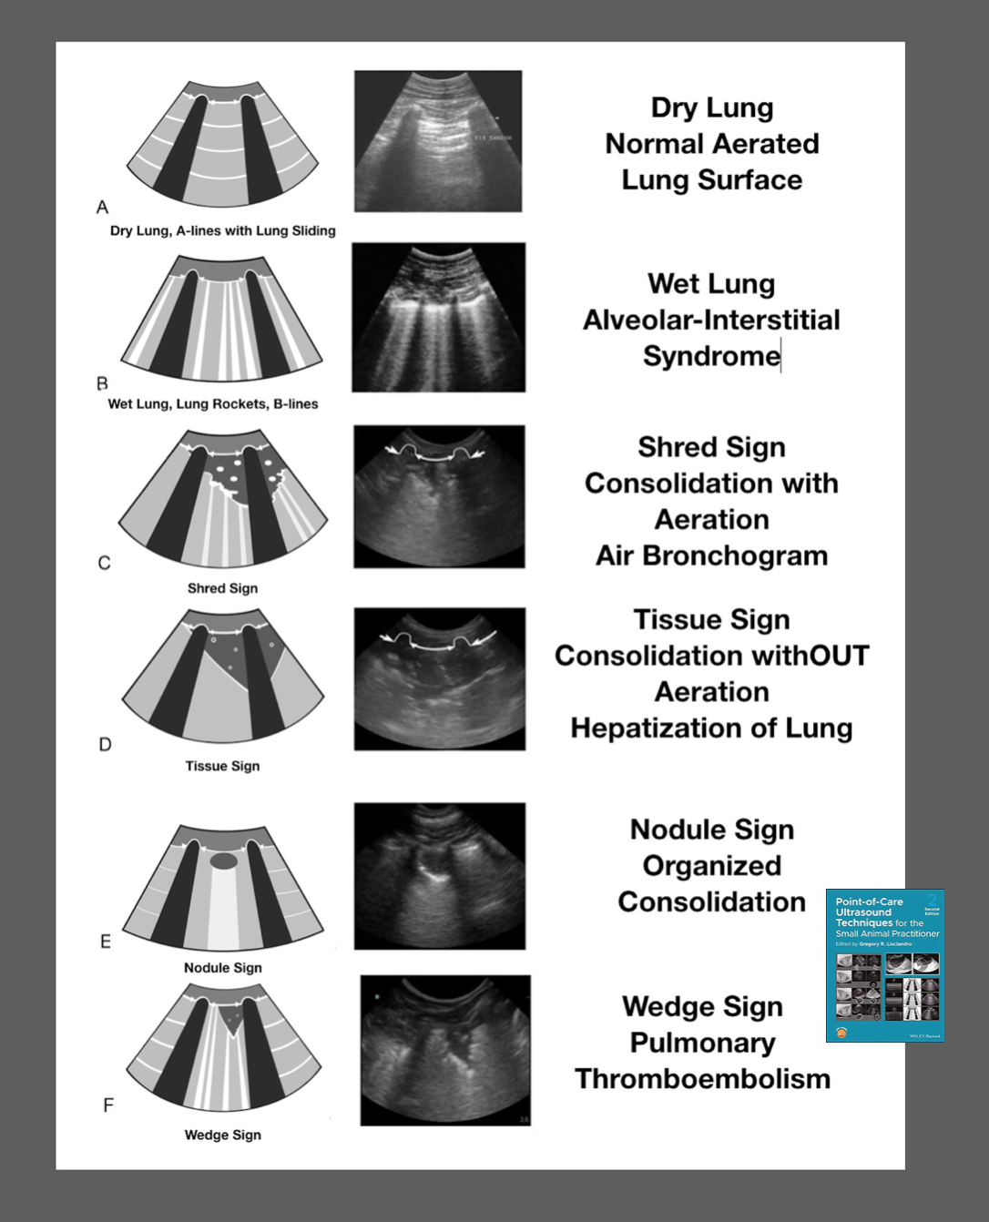 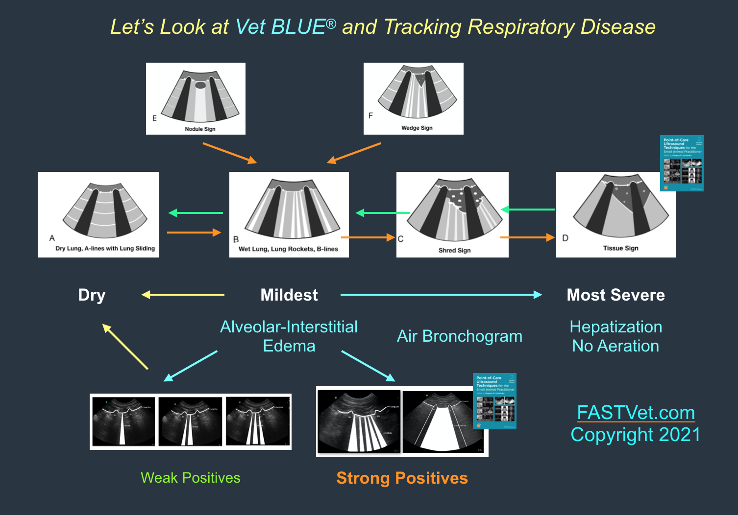

**Figure Left. Vet BLUE® Visual Lung Language and Its 6 Signs.** *This material is reproduced and modified with permission of John Wiley & Sons, Inc.,* [*Point-of-Care Ultrasound Techniques for the Small Animal Practitioner*](https://www.amazon.com/Point-Ultrasound-Techniques-Animal-Practitioner/dp/1119460980/ref=sr_1_1?crid=2W3RO79YXBLKT&keywords=Lisciandro+ultrasound&qid=1674252243&sprefix=lisciandro+ultrasoun%2Caps%2C203&sr=8-1)*, Wiley ©2014, ©2021 and Greg Lisciandro, Hill Country Veterinary Specialists and FASTVet.com © 2021.*

**Figure Right. Use of Vet BLUE® for Tracking Respiratory Conditions.** A recent clinical study showed the clinical utility of using Vet BLUE® for left-sided congestive heart failure patients to guide diuretic use and heart failure treatment. Similar use with any respiratory condition can be applied by understanding the figure. *This material is reproduced and modified with permission of John Wiley & Sons, Inc.,* [*Point-of-Care Ultrasound Techniques for the Small Animal Practitioner*](https://www.amazon.com/Point-Ultrasound-Techniques-Animal-Practitioner/dp/1119460980/ref=sr_1_1?crid=2W3RO79YXBLKT&keywords=Lisciandro+ultrasound&qid=1674252243&sprefix=lisciandro+ultrasoun%2Caps%2C203&sr=8-1)*, Wiley ©2014, ©2021 and Greg Lisciandro, Hill Country Veterinary Specialists and FASTVet.com © 2021.*

**Integrating Information**

Vet BLUE® should be integrated with TFAST® findings including TFAST® fundamental echocardiography to determine the cause for "Wet Lung." For example, diffuse "Wet Lung" with an enlarged left atrium supports left-sided congestive heart failure; however, in the absence of left atrial enlargement, other "Wet Lung" conditions are considered. More information on Global FAST® Non-echo Fallback Views [here](https://fastvet.com/ecc-and-im-blog-global-fast-fallback-views/).

**Comparison of Vet BLUE**® **to Thoracic Radiography and Computed Tomography**

Lung ultrasound (LUS) has been shown in people to be clearly superior to chest radiography for "Wet Lung Conditions", pneumonia, and pneumothorax. Vet BLUE® has been shown to exceed thoracic radiography (TXR) for the detection of "Wet Lung" (Ward, Lisciandro, DeFrancesco *JVECC* 2018) and perform nearly as well as Computed Tomography (CT) in pulmonary contusions, a "Wet Lung" condition (Dicker et al. *JVECC* 2020). Vet BLUE® appears to be a good lung metastasis check with similar performance as TXR (Kulhavy and Lisciandro *JVECC* Abstract 2015; Pacholec et al. *Vet Record* 2021).

**Always Strive for The Global FAST**® **Approach**

Selective imaging leads to “confirmation bias error” and “satisfaction of search error” and is a major concern with the veterinary POCUS (V-POCUS) movement. For example, a Vet BLUE® profile on a coughing large breed dog is "Dry Lung All Vet BLUE® views" with an unremarkable TXR. Thus, the conclusion is drawn that the dog has upper airway or bronchial disease and gets treated and worked up *erroneously when* TFAST® fundamental echocardiography detects an enlarged heart and poor contractility supportive of dilated cardiomyopathy (missed radiographically) and the cough is from left atrial enlargement and mainstem bronchial compression. Treatment is initiated while the patient waits for confirmation by complete echocardiography. The same dog has AFAST® findings of a splenic mass with a negative AFAST® abdominal fluid score of 0. So, always strive for the Global FAST® Approach that provides an unbiased set of 15-data imaging points of the abdomen and thorax including heart and lung surface. In this case example you can see how integrating the Global FAST® Approach as an "extension of the physical exam" provided a much better initial patient assessment that was more accurate over targeted or focused V-POCUS, thoracic radiography, physical exam, and blood and urine testing.

**References & Further Reading**

1. **Figures** and **Tables** for these **TFAST®** **Proceedings** are [here](https://fastvet.com/fastvet-supplemental-tables-and-figures-for-vet-blue-proceedings/).
2. **FASTVetTM** Free Resources [here](https://fastvet.com/category/free-resources/); Goal-directed Templates [here](https://fastvet.com/most-updated-global-fast-goal-directed-templates/); Webinars [here](https://fastvet.com/category/archived-webinars/); Global FAST® Training [here](https://fastvet.com/learn-in-person/); Video How to Perform Global FAST® Efficiently [here](https://fastvet.com/global-fast-blend-how-to-do-global-fast-in-standing-and-most-efficiently/); Anaphylactic Hemoabdomen Webinar in Dogs [here](https://fastvet.com/fastvet-monthly-webinar-july-2022-updated-information-on-medically-treated-canine-anaphylactic-hemoabdomen-presented-at-the-acvim-forum-2022/); other Free Resources [here](https://fastvet.com/category/free-resources/).
3. [Point-of-care Ultrasound Techniques for the Small Animal Practitioner](https://www.amazon.com/Point-Ultrasound-Techniques-Animal-Practitioner/dp/1119460980/ref=sr_1_1?crid=2W3RO79YXBLKT&keywords=Lisciandro+ultrasound&qid=1674252243&sprefix=lisciandro+ultrasoun%2Caps%2C203&sr=8-1), 2nd edition, Ed. Lisciandro GR, Wiley ©2021. Click [here](https://www.amazon.com/Point-Ultrasound-Techniques-Animal-Practitioner/dp/1119460980/ref=sr_1_1?crid=2W3RO79YXBLKT&keywords=Lisciandro+ultrasound&qid=1674252243&sprefix=lisciandro+ultrasoun%2Caps%2C203&sr=8-1).
4. **Lisciandro GR,** Lisciandro SC. Chapter 22: POCUS: Vet BLUE-Introduction and Image Acquisition. *In* [Point-of-care Ultrasound Techniques for the Small Animal Practitioner](https://www.amazon.com/Point-Ultrasound-Techniques-Animal-Practitioner/dp/1119460980/ref=sr_1_1?crid=2W3RO79YXBLKT&keywords=Lisciandro+ultrasound&qid=1674252243&sprefix=lisciandro+ultrasoun%2Caps%2C203&sr=8-1), 2nd Edition, Ed. Lisciandro GR. Wiley Blackwell: Ames IA 2021.
5. **Lisciandro GR,** Lisciandro SC. Chapter 23: POCUS: Vet BLUE-Clinical Integration. *In* [Point-of-care Ultrasound Techniques for the Small Animal Practitioner](https://www.amazon.com/Point-Ultrasound-Techniques-Animal-Practitioner/dp/1119460980/ref=sr_1_1?crid=2W3RO79YXBLKT&keywords=Lisciandro+ultrasound&qid=1674252243&sprefix=lisciandro+ultrasoun%2Caps%2C203&sr=8-1), 2nd Edition, Ed. Lisciandro GR. Wiley Blackwell: Ames IA 2021.
6. **Lisciandro GR**. Chapter 36: POCUS: Global FAST-Patient Monitoring and Staging. *In* [Point-of-care Ultrasound Techniques for the Small Animal Practitioner](https://www.amazon.com/Point-Ultrasound-Techniques-Animal-Practitioner/dp/1119460980/ref=sr_1_1?crid=2W3RO79YXBLKT&keywords=Lisciandro+ultrasound&qid=1674252243&sprefix=lisciandro+ultrasoun%2Caps%2C203&sr=8-1), 2nd Edition, Ed. Lisciandro GR. Wiley Blackwell: Ames IA 2021.
7. **Lisciandro GR,** Puchot ML,Gambino JM, Lisciandro SC. The Wedge Sign: A Possible Lung Ultrasound Sign for Pulmonary Thromboembolism. *J Vet Emerg Clin Care 2021.*
8. Pacholec C, **Lisciandro GR**, Masseau I, et al. Lung ultrasound nodule sign for detection of pulmonary nodule lesions in dogs: Comparison to thoracic radiography using computed tomography as the criterion standard. *Vet J* 2021 Jul 31;105727.doi: 10.1016/j.tvjl.2021.105727. Online ahead of print.

*A summary of all our 20+ peer-reviewed clinical studies may be found [here](https://fastvet.com/publications-references-validating-fastvet-techniques/).