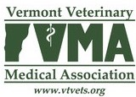

Best Practices for Calf Transport and Slaughter

Adopted by the VVMA Executive Board
June 12, 2023

The VVMA supports the VT Livestock Advisory Council best practices statement for calf transport and the AVMA Guidelines for the Humane Slaughter of Animals.

Resources:
https://agriculture.vermont.gov/animal-health/animal-welfare#transport

