How to incorporate a modified hoof cast into equine veterinary practice
Stephen E. O’Grady, DVM, MRCVS*†; and Derek Poupard, CJF, DipWCF⸙
Author’s address: Virginia Therapeutic Farriery, 833 Zion Hill Rd, Keswick, VA 22947† and 1 Taylors Field Dullingham Newmarket CB8 9XS United Kingdom *Corresponding author e-mail: sogrady@look.net
Introduction
Maintaining a healthy equine foot as well as successfully treating lameness attributed to the foot requires appropriate farriery which is of paramount importance in equine veterinary practice. The equine veterinarian is responsible for the overall health of the horse, including the foot; however, the foot is the one area of the horse that generally requires input from another professional, the farrier. Historically, the use of hoof casts is not new to veterinary medicine as they are used to treat distal phalanx fractures, laminitis, hoof capsule avulsions, and countless other problems affecting the equine foot. Recently, hoof casts have gained popularity in farriery to maintain horses in the barefoot state, to treat hoof wall defects, white line disease and to manage compromised feet where shoes are not an option. However, there are innumerable occasions when a hoof cast could be beneficial in routine equine veterinary practice. This paper describes the application of a modified hoof cast that is relatively simple for any equine clinician to apply. The cast application described here is basically limited to the outer hoof wall which is different than the traditional foot cast used in equine practice.
Hoof casts
Hoof casts are used in veterinary practice to treat certain foot problems, however; the first author was never an advocate for using them in farriery. The main concern was the restrictive nature of the cast that impeded the physiologic function of the foot especially the heel structures and the inconsistent methods of application. Recently, a revolutionary new technique for cast application has been introduced. Revolutionary in the sense that, the cast adheres to and is limited to the outer hoof wall; this allows the section of the cast across the heels to be removed, thus eliminating the constrictive nature of the cast. The technique is geared toward providing strength, protection and stability to the hoof capsule yet does not interfere with or compromise physiologic foot function. There are many reasons why this cast application should become a routine treatment for foot issues in equine veterinary practice. The use of a foot cast presents a viable option to equine veterinarians that can be used on its own merits when necessary or combined with traditional farriery.
Indications
Injuries to the equine hoof capsule and lameness related to the foot are frequently encountered in equine practice. Injuries to the hoof capsule, especially in the acute stage, can often be treated with a hoof cast. Damage to the hoof capsule such as hoof wall loss, toe or quarter cracks, white line disease resections, avulsions, etc. are often acutely painful and can be stabilized using a hoof cast. Obviously, the appropriate drain will need to be incorporated into the cast when necessary, to prevent infection. The first author has been successful rehabilitating many hoof capsule distortions in the barefoot state^{1,2}. Reluctance to remove shoes and leave the horse barefoot has always been for fear of damage to the hoof capsule and resultant discomfort for the horse. Here, the cast affords protection which promotes comfort while allowing the physiological benefits of being barefoot. Another use is when a horse is trimmed too short or sustains foot bruising; a cast can be applied that protects the compromised structures of the hoof capsule.
Scenarios where a cast is beneficial in equine practice:
- Rehabilitating the foot in the barefoot state
- Transitioning the horse from being shod to barefoot.
- Permitting light exercise when horse is being maintained in the barefoot state.
- Stabilizing / increasing thickness of a thin or compromised hoof wall.
- Stabilizing hoof wall defects (toe, quarter, and heel cracks)
- White line disease
- As an alternative to glue-on shoes.
Application of the cast
The cast application described here will be different than the conventional application. Trimming the foot prior to cast application is always a crucial step and the basics guidelines for trimming will apply whether the foot is being rehabilitated for a hoof capsule distortion, being transitioned to remaining barefoot or reenforcing the hoof wall prior to applying shoes ^{2,3,4}. Briefly, the solar surface of the foot to be cast is brushed briskly with a wire brush and no horn is removed with a hoof knife. A line is drawn across the widest part of the foot and the heels of the hoof capsule are trimmed to the base of the frog or to the same plane as the frog. If the frog is receded below the bearing surface of the hoof wall, every attempt should be made to trim the heels to the same plane as the frog. If the frog is prolapsed below the ground surface of the foot, a few days of weight bearing on the frog will put it on the same plane as the frog. Toe length is decreased using the nippers or rasp in a vertical direction thus preserving the horn on the solar surface and creating approximate proportions on either side of the line drawn across the middle of the foot. Finally, the edges of bearing border of the hoof capsule are rounded using the rasp at an angle (Figure 1A).
To apply the cast, the outer surface of hoof wall at the heels and frog sulci are cleaned with a rasp and the remainder of the outer surface of the hoof wall is sanded using a medium grit sanding block ª (Figure 1B & 1C). A thick focal layer of an acrylic adhesive compound ^{b} is applied to the outer surface of the hoof wall at the heels which will act as the anchor point to stabilize the cast. A thin layer of acrylic is randomly spread on the remainder of the outer hoof wall stopping below the coronet. Starting at the heels, a roll of either 2 or 3-inch casting tape ^{c}, depending on the size of foot and thickness of the cast desired, is wrapped around the perimeter of the foot (Figure 2A & 2B & 2C). The cast is applied without being immersed in water first as this allows the acrylic to permeate between the fibers of the cast, thus forming a bond with the outer hoof wall. The cast will extend to just below the coronet and at least .5 inch or more below the hoof wall to create a fold onto the ground surface of the foot. The cast can be further thickened by creating some folds at the heels and or the quarters by layering the cast back and forth and then enveloping the folds as one continues to wrap around the perimeter of the foot. With the cast in place, a sponge soaked in water is used to thoroughly wet the cast, causing it to cure. This step is unique to this application as the acrylic incorporated in the first few layers of the cast that adheres to the outer hoof wall is now beginning to cure and the water added to the remainder of the cast causes the resin to begin the curing process. Interestingly, neither the reaction of the acrylic or the cast resin interferes with the other. Finally, the cast is covered with plastic compression wrap ^{d} and the foot is placed on the ground to flatten the folds of the cast on the solar surface of the foot. (Figure 3A & 3B & 3C & 3D).
The unique part of this application is the removal of the section of cast that bridges the bulbs of the heels. Once the cast has cured, using the edge of the rasp, the cast is scored on either side of the frog from the frog sulci at the base of ther frog to the edge of the cast at the hairline of the heel bulb. The score lines are now cut through using a thin hoof knife or some form of saw blade or gigli wire. The first author uses a hacksaw blade inserted in a handle ^{e} which can be used with one hand and cuts easily through the cured cast. The section of cast that covers the base of the frog is removed and the edges of the cast are smoothed with a rasp or sanding block and blended with the hoof wall at the heels (Figure 4A & 4B & 5C).
Finally, the foot is placed on a hoof stand and any cast material above or at the coronet is removed by light rasping or again using the sanding block to blend the cast material with the dorsal hoof wall; as the acrylic does not extend to the coronet and the cast is not adhered to this area (Figure 5).
A
The hoof cast is worn up to sixty days on average in general practice and is trimmed the same as the outer hoof wall during regular shoeing intervals. If the horse is kept in a continious wet envirnoment, the cast is waterproof but the moisture will affect the adhesive properties of the cast and it will begin to losen and peel off. The cast is simply removed by rasping it off the outer hoof wall. The authors have seen no contraindications for using this casting technique, however, casts should not be used to cover areas of infection, sensitive tissue or full thickness defects without taking the appropriate precautions such as a protective barrier or a drain.
Discussion
It should be noted that the cast described in this paper differs from other casting tape presently being used. The fibers in the weave of this cast are not packed as tight which allows the acrylic adhesive to permeate the cast and makes the cast lighter. Furthermore, 25% more resin has been added to the cast to expediate the curing process. The emphasis here should not be placed on the casting tape but rather on the unique application of the cast. It is readily apparent that the application of a hoof cast as described above adheres to the outer surface of the hoof, affords protection, and provides strength and stability to the hoof capsule while allowing the full physiological function of the foot. The increase bulk added to the hoof wall allows a shoe to be attached in cases where nailing was difficult. Furthermore, the cast forms an interface at the heels that adds protection and decreases wear that arises from the heel moving against the shoe or the ground during weight bearing.
There are innumerable foot problems that can be treated with this type of cast methodology in equine veterinary practice. The ability by veterinarians and farriers to confidently apply this casting technique is easily acquired after doing a few cases. It can also be used as a topic to enhance communication between the veterinarian and farrier.
The structures of the equine foot have the unique ability to adapt, strengthen, change shape, and improve the integrity of the hoof capsule structures if given a period without shoes. This is important in lameness cases that are localized to the foot as most of these cases will be associated with some form of hoof capsule distortion. Horses wanting to be left barefoot after being shod for any length of time require a transition period to allow the feet to strengthen and adapt after having the interface (shoe) removed. In both instances, applying a cast affords stability and protection to the hoof capsule without interfering with any of the physiological functions of improving the structures. The second author has found a marked benefit from using a hoof cast on feet, especially horses with thin hoof walls) that previously had glue-on shoes applied. Here the shoe is nailed into the cast material rather than the hoof wall thus allowing numerous shoe applications without further compromising the hoof wall integrity. This technique is quite helpful in thin-walled horses as it prevents a close or mis-placed nail. Damage to the hoof capsule including hoof wall loss, hoof wall defects such as toe and quarter crack, white line disease and the necessity to perform how wall resection are frequently encountered in equine practice. Detached or diseased hoof wall can be removed, the area debrided, when necessary, impression material ^{f} added to act as an interface and restore shape to the capsule and then placed in a cast (Figure 6). Determining the cause and combined with the appropriate farriery, both a toe crack and quarter crack can be stabilized using this type of hoof cast. A cast is used on the entire hoof capsule with a toe crack and the cast is sectioned from the toe quarter to the heel on the affected side of a quarter crack. This type of repair is easy, strong, adheres well and is non-invasive. In fact, the authors feel that using a full or partial hoof wall cast for stability may become the treatment of choice for repairing hoof wall defects.
Conclusion
This method of cast application has huge implications for both veterinarians and farriers, whether the horse is shod or barefoot. The reluctance of many veterinarians, farriers, and horse owners to remove the shoes to rehabilitate the hoof capsule or transition to being barefoot is due to the initial discomfort the horse may experience and the damage to the hoof capsule without the protection of a shoe. Here is a hoof cast application that will bridge that gap while allowing the structures of the hoof to adapt, strengthen, change foot conformation, and restore itself. The potential uses for this hoof cast application are unlimited and only now being imagined.
Acknowledgements
Declaration of Ethics
The Authors have adhered to the Principles of Veterinary Medical Ethics of the AVMA.
Conflict of Interest
Dr. Steve O’Grady has no financial interest in any product described in this manuscript. Derek Poupard is the owner of Hoofcast LLC and is currently involved in the commercialization and distribution of the casting tape described in this manuscript.
References & Footnotes
1. O’Grady SE. Various aspects of barefoot methodology relevant to equine veterinary practice. Equine Vet Edu 2016 28(6):321-326.
2. O’Grady, S.E. Farriery for Common Hoof Problems. In: Baxter GM, ed. Adams and Stashak’s Lameness in Horses 7th ed. Ames, IA: Wiley-Blackwell, 2020;1112-1133.
3. O'Grady SE, Poupard DA. Physiologic horseshoeing: an overview. Equine Vet Edu 2003;13:330-334.
4. O’Grady, SE. Guidelines for Trimming the Equine Foot: A Review. Proceedings, Am Assoc Equine Pract 2009 55;218-225.
a. 3M® sanding sponge - 3M Center St. Paul, MN 55144-1000
b. Equilox® adhesive system - Equilox International, Inc.110 NE 2nd Street Pine Island, MN 55963
c. Hoofcast® - Farrier Products Distribution 361 Haven Hill Rd, Shelbyville, KY 40065
d. Equilox® compression wrap - Equilox International, Inc.110 NE 2nd Street Pine Island, MN 55963
e. Hacksaw blade handle – Amazon.com, inc.
f. FootPro® impression material - Farrier Products Distribution 361 Haven Hill Rd, Shelbyville, KY 40065

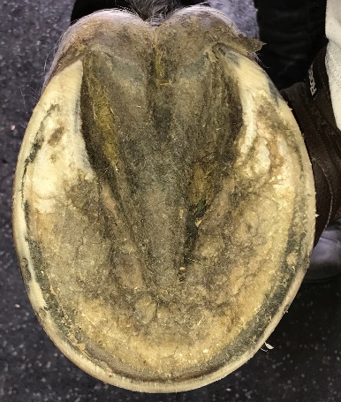
C
B
A
Figure 1. (A) foot being trimmed to remain barefoot that shows a black line drawn across the widest part of the foot, yellow line is approximate proportions on either side of the line and the red line shows the hoof wall and frog on same plane. (B) outer surface of the hoof wall at the heels being cleaned with a rasp and (C) outer surface of hoof wall being sanded to remove any debris.
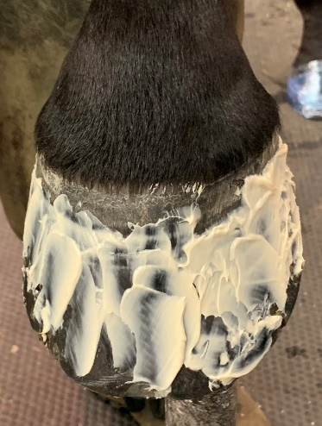
C
B
A
Figure 2.( A) a thick focal layer of acrylic being applied to the cleaned heels (B) a light coating of acrylic applied to the outer surface of the hoof capsule (C) cast is started at the heel and continued around the perimeter of foot (note how the acrylic permeates the casting tape).
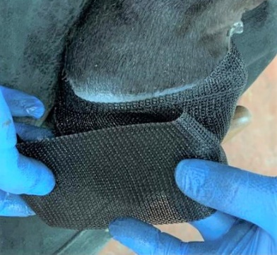
D
C
B
A
Figure 3. (A) cast folded and covering the bearing border of the foot. (B) cast folded back and forth to increase thickness. Sponge used to wet cast when in place (C) and (D) shows foot covered with plastic wrap.
C
B
A
Figure 4. Cast is scored using the edge of a rasp (A) Scores are cut through using a hoof knife (B) and frog/bulb section of cast is removed. Cut edges of cast smoothed up and blended into heel bulbs with a rasp (C).
A
B
C
Figure 5. A-B-C Lateral, dorsal, and solar view of the cast in place. Note the protection and stability provided at the heels (C).
B
A
Figure 6. A shows impression material used to fill area of hoof wall loss and put shape back into hoof capsule. B is solar surface of the foot with cast in place and heel section removed.

